**Grafana + Prometheus**

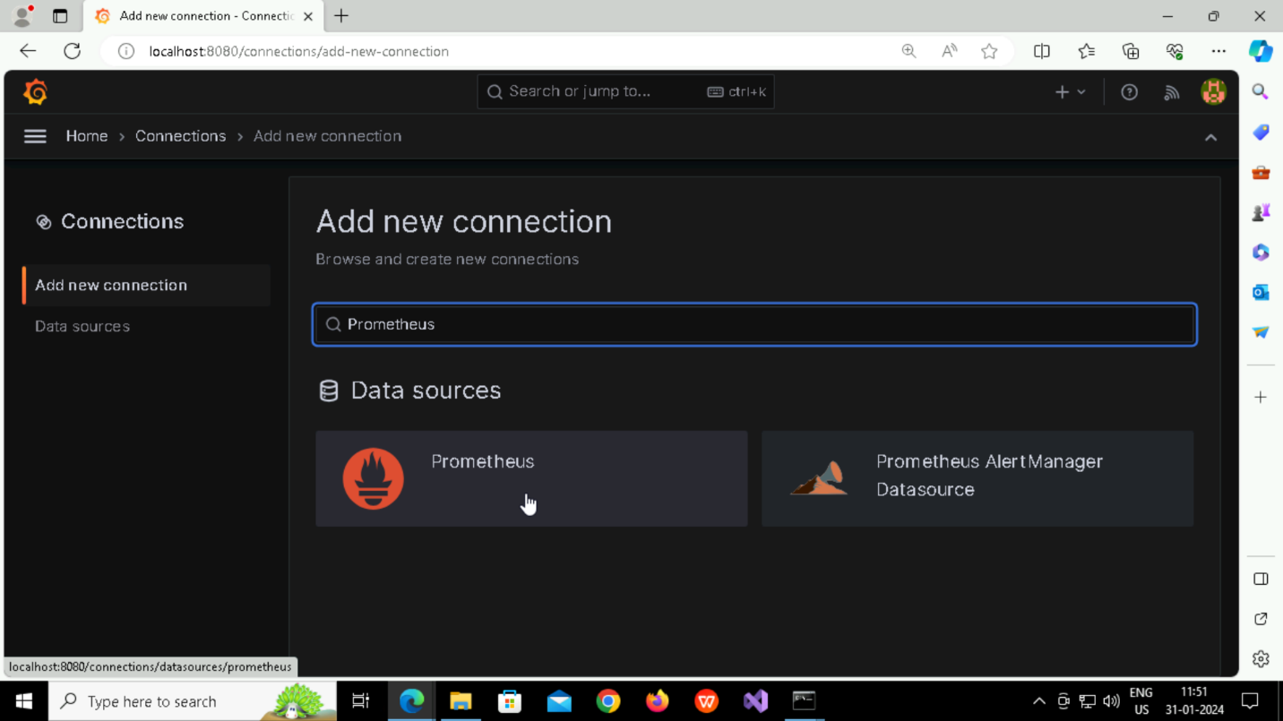

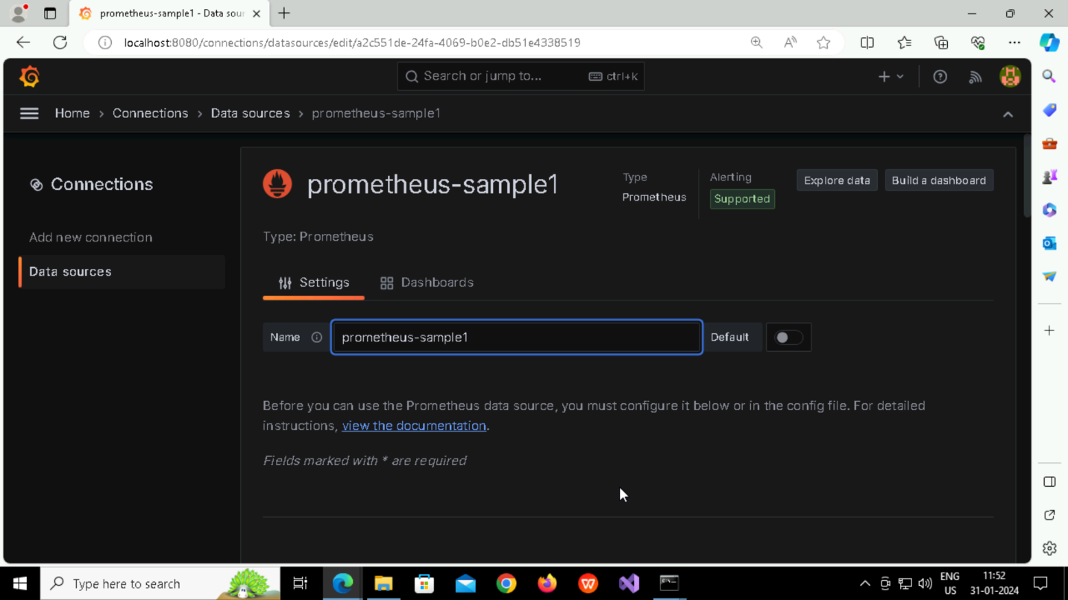

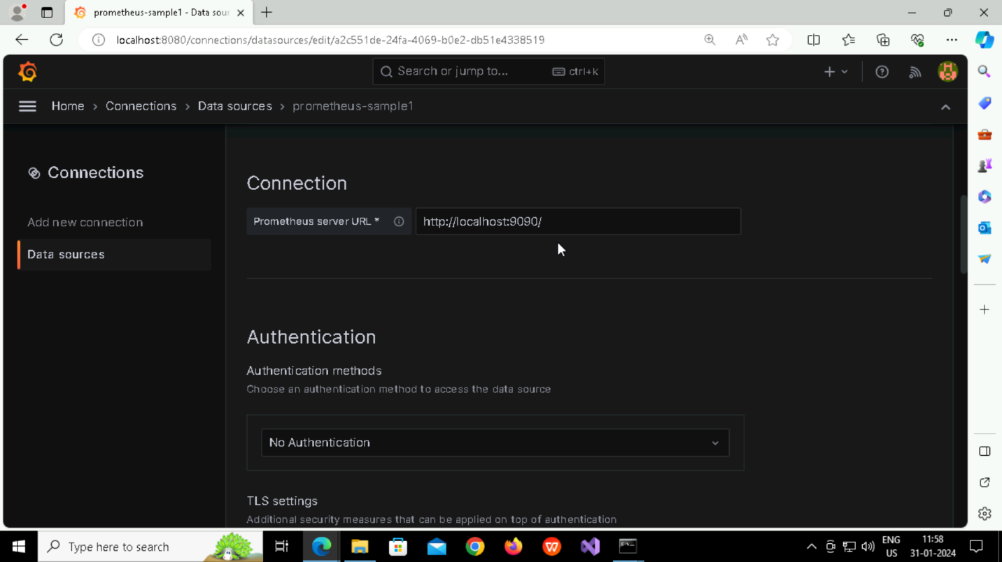

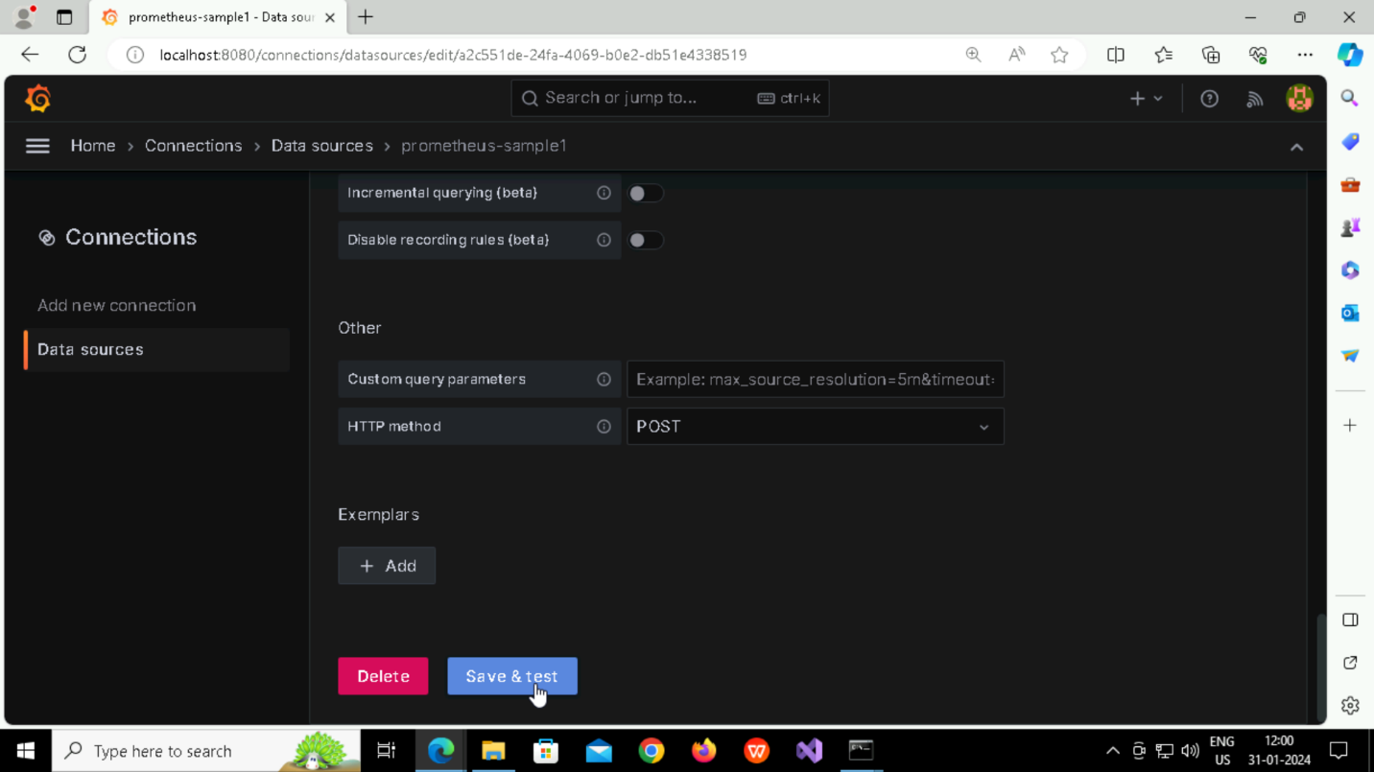

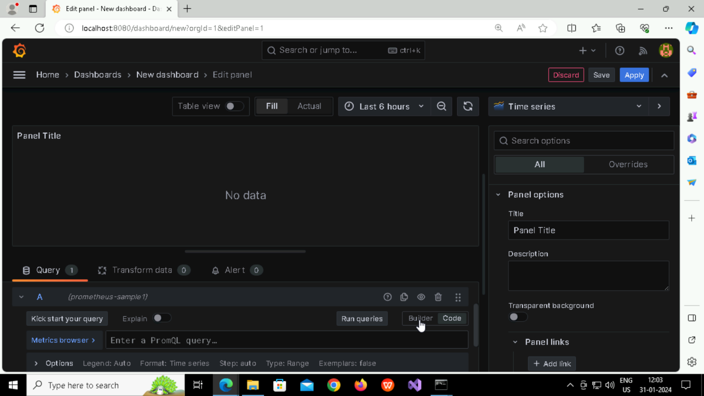

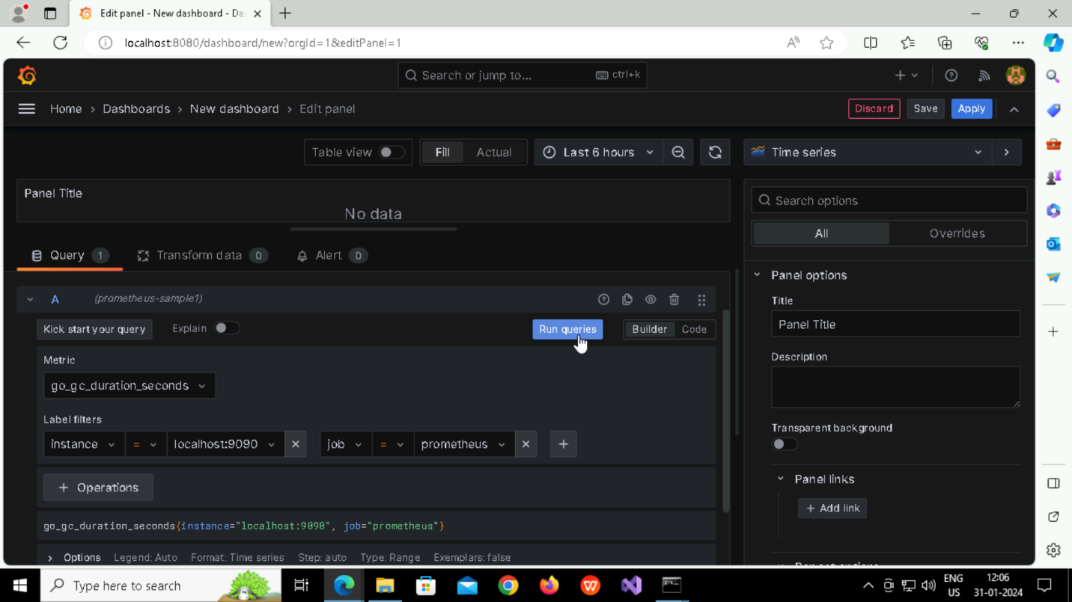

**Adding another Panel (DNS Lookup)**

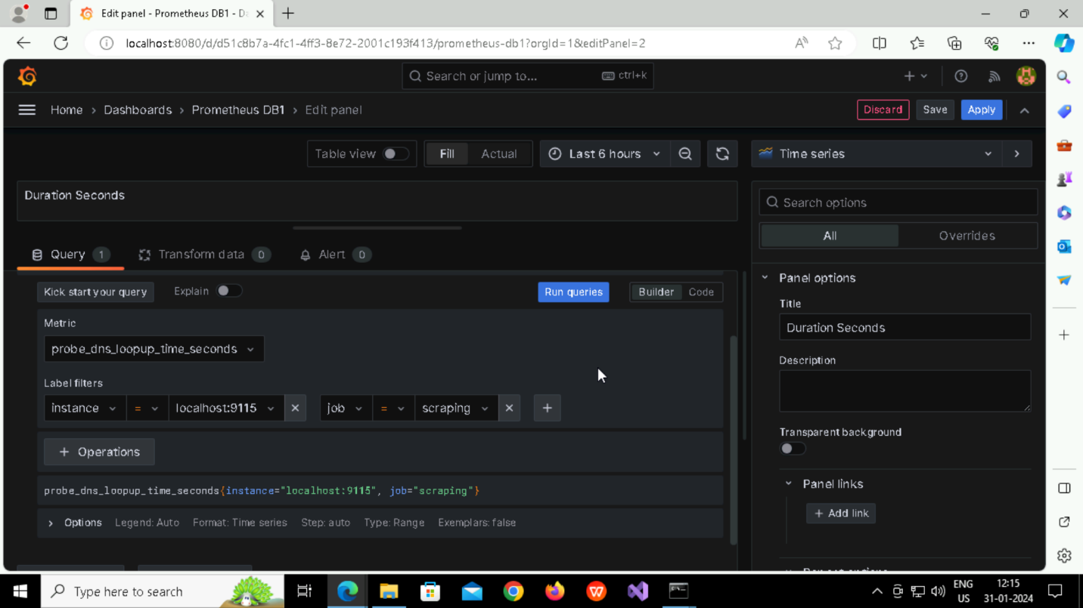

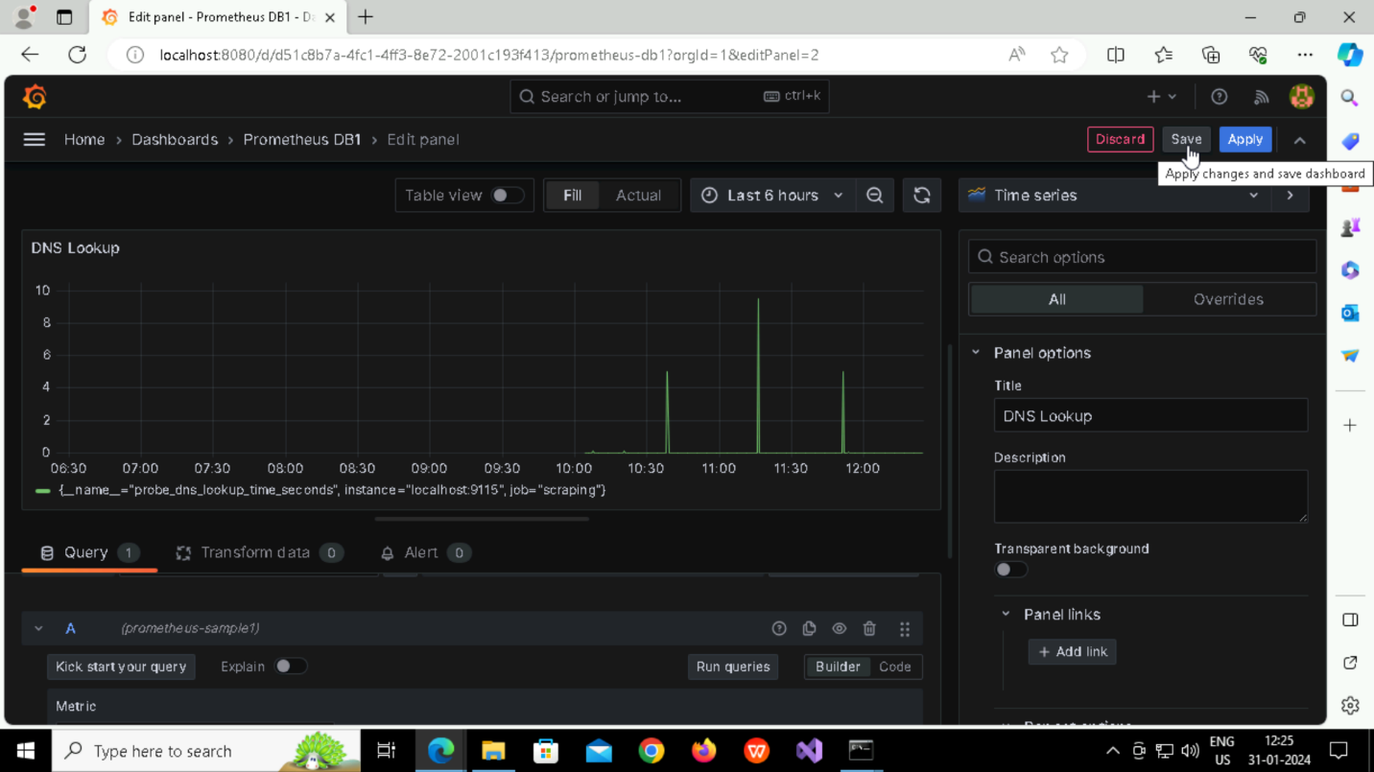

**Adding another Panel (Connecting with Processing Time)**



